Quarterly Minutes Membership/Board Meeting – GPAH
Sunday, January 25, 2026, via TEAMS
1:00 p.m.
Meeting called to order: Ryan B. at 1:07 PM

Board Members Present: Ryan Behenna, Michael Lorenzen, Sherrie Kent, Amy Bradford, Chris Ford, Sherri Clark, Chelsea Hertzler, Cynthia Crochet, Julie Caprette, Rebecca Schauer

Membership Guests: Jennifer Camisa, Bev Points, Laura Weiner, Elaina Mukhina, Kelsea Ziegler, Trieu Nguyen, Maureen Brunetti, Denise Manos, Michelle Graham, Jeff Noxen

Treasurers Report: Cynthia C. Presentation of the flow of funds for GPAH 4rd quarter. Ryan put the power point slide deck on the share screens created by Cindy C.
Motion to accept financials as presented: Julie C.– motion Amy B. 2nd Motion approved.

Minutes 10/26/2025: Sherrie K. We did not get enough participate from board to approve minutes for last membership meeting. Only got through the discussion/additions/corrections part.
Motion: Accept minutes as corrected. Julie C. 2nd Amy Approved unanimously

Compliance Officer - Rebecca S. advised membership that all board members were almost finished with rewrite of the GPAH policies and procedures (P&P) manual and Roles and Responsibilities for Committees will go before the board can discuss and vote. Once approved, membership will have better grasp of all the changes to GPAH since reinstating the adoption program and conducting business without a central kennel-based programs.

Permanent Foster Report: Sherrie K. and Sherri C.

Emma – Doing well. Changed heart meds.
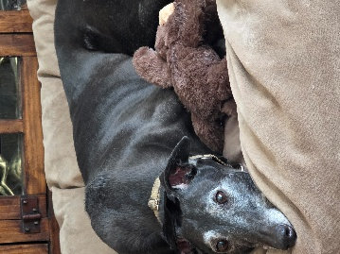

Elias – Back-end weakness increasing. He is still really grumpy. Vet wants to try shots but need approval once know costs.
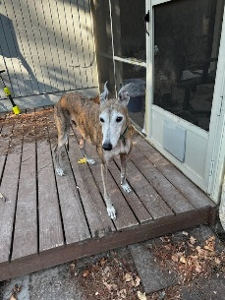

Tonopah – Excerpts from email from Linda Lee – Foster Mom
I was about to reach out to you about Tonopah - great minds think alike! Tonopah is thriving - he is silly, sweet and adores his food, Michael and “Uncle Dave”, a friend who’s moved down from Seattle to retire.
His recent visit to our vet was good news - no fleas, ticks, parasites or issues in his digestive/coronary systems. His vet is recommending another teeth cleaning, since he is showing more tartar building up. It’s not going to be as expensive as last year, since he shouldn’t have any extractions this time. Bloodwork is scheduled for 4/2 and dental cleaning is set for 4/9. I’ll keep you updated in April, with info about the bloodwork and dental cleaning. He does have anxiety issues when Michael leaves the house, when he doesn’t think he’ll get fed, or when he needs to go outside to go potty in the middle of the night. Our Vet agrees that his TBI may be causing the anxiety. We are now telling him what we will be doing so he has time to absorb the info in his brain.
Otherwise, he is a very happy greyhound who makes us laugh and gives us so much love.
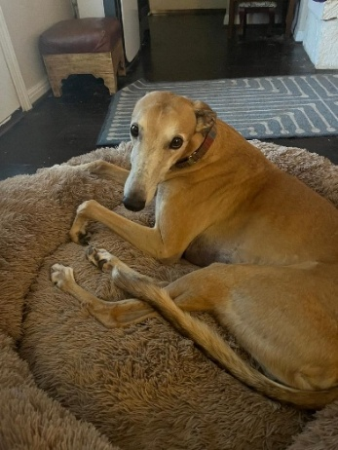

Tucker – Excerpts from email from Sharry M. - Foster Mom
Tucker is 10 1/2 years with some white around the face from too many kisses. He got a good health review (With his heart issues) in September 2025 and due for a 6month check up March 2026. No medication change, same dosages for more than 5 years. He has been on 3 meds since he was 2 1/2 years old. He really spoiled rotten as he wasn’t expected to live more than a year back in 2017. He thinks everything is for him and doesn’t share well. He is very affectionate to me and those he likes. We lost Sky to cancer last February and Tucker mourned her openly for more than 6 weeks. He slept with her blanket for two months and would not share with Eagle. Tucker gets on furniture. Tucker is slowing down a bit. He hasn’t been on any drugs for emotional stress, spooky behavior more than 5 years. His reaction is fear/freeze and I can work with 80# and I keep his stress to as minimally as possible, rides in the car and yearly vet visits which now will be every 6 months. I just changed 2 drugs to H-E-B pharmacy and the cost for the 2 was less than 1 from on-line. It has been a constant battle for 8 years with cost and reliability. One drug is compounded locally for a number of years and the price has been the same. The manufacturer became unreliable and cost skyrocketed up and then sort of down and not available.
I want to thank the board for paying for Tucker’s meds and medical checkups. We stopped going to specialist for expensive tests as they were only showing what they were interested in and offered nothing to improve his quality of life but scaring him and I really think were actually causing more harm than good. I switched to Dr Heimlich till he retired, Dr A. Wolf for 2 years and now we go to Dr Pittenger. It’s about 45 min or 1 1/2 hrs with traffic one way but he is a wonderful veterinarian and everyone is really great and helpful. When I offered to foster Tucker it was to get him out of the kennel and have a home for as long as he had to live in 2017 maybe a year, here it is 2026. He came from that hellhole blood bank scared to death of his own shadow. In my home he is king of the hill until I, mom reminds him who is boss.
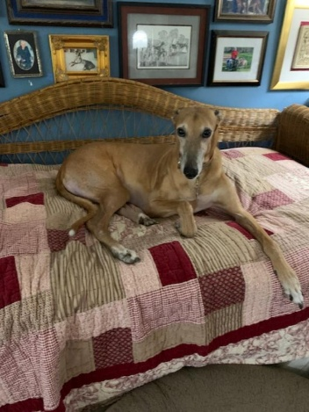

Adoption Committee Updates:
Adoptable Dogs: Ryan B. presented the slides of our adopted dogs for the year.
Poppy fostered by George L. Ended up adopting him.
Ace (10-month-old) fostered by George L. Due to his puppy ways, he needed more in-depth training to be adoptable. Ace checked into boarding/training The Mannered Mutt in Conroe. Training cost donated to GPAH.
Adoptions: Ryan B.
Maggie Adopted by Julie and Dave C.
Freya (fka Hermioonie) Adopted by Christina A.
Foster Homes: Sherrie K. Contacted all foster homes getting ready for Australian dogs in February. Pending date of flight.
Adoption Applications: Ryan B.
Approved and waiting for right dog: 4
Pending approval: 2
Foster Home Applications Pending: 0
Old Business:
The 2-month-old grey’s owner never contacted GPAH to complete surrender.

New Business:
Fundraising: Lauren and Rebecca are researching an ETSY store for GPAH. Many items will be available and members can select art to go on items. No quotas and they will handle all sales tax and shipping issues. Will need a way to handle the ETSY account finances.
Discussion presented by Cindy C. that a separate bank account for ETSY Fundraising to send receipts for all merchandise purchased and a separate credit card to be used to keep all ETSY fees together. This makes it easier for treasurer with accounting of finance reports for GPAH.
Motion: Mike L. - To set up separate bank account for the ETSY store and a separate credit card to handle ETSY fees to simplify treasure accounting. 2nd Julie C Motion approved unanimous
Auctions: Lauren W volunteered to join committee to increase the on-line auctions to raise more funds and clear out the backlog of donated items.

Membership Info for BUZZ: Mike L. Membership drive in progress. Mike will get the new and renewal memberships loaded into BUZZ, send him the forms.
GPA National Survey/Dues: Sherrie K. Need to add to BUZZ a way to get data to complete the annual survey report for GPA National survey and dues. Need to add a way to list the dog’s Name, Racing Name, and Country of Origin to send to GPA National. They need this information to calculate chapter dues owed to National. Mike will get with BUZZ and figure out how best to capture this information for the future.

Goals for GPAH 2026: Ryan B.
Adoptions: Goal for 2026 of getting 12-26 greyhounds homed.
Membership: Increase membership so will have larger pool of members to fulfill tasks.
Events: Increase public events to get better visibility of dogs available for adoption.
Roles and Responsibilities and Policies and Procedures: Finish tweaking and get approved for publishing to membership.

Social media: Michelle Graham found a way to reinstate the Instagram and link to Facebook to reach more potential members and adopters. She will assist Amy and Chelsea with whatever they need for social media.

Newsletter: Chelsea H. – Request to change schedule of newsletter from Quarterly to Bi-Monthly. This will allow it to be more current for events and articles highlighted.

Motion: Julie C. To make a change in the scheduled release of GPAH newsletter from quarterly to bi-monthly. 2nd: Amy B Motion approved unanimous

Adoption Policy Change: Ryan B.
Discussion among board back in 2023-2024. it was decided that members would not be allowed to adopt ahead of any adoption applicants, already approved to adopt and waiting until a suitable match for a greyhound was found, when they decided to accept fostering (foster with intent). This would not be fair to potential adopters and new members that had been waiting, sometimes many months. As this was not voted on by the membership and included in a formal setting of the minutes or power point, it was asked of the membership to make a one-time exception for 2 members that already were fostering dogs, the opportunity to go ahead and adopt the dog currently in their foster home. And if membership approved, to document that the foster home in the future, must declare ahead of time, before they start fostering that they have the intent of adopting their foster. And potential new adopters will not feel we ignore their place in line for a greyhound.
Motion: Cindy C. That the foster must have an adoption application pending, and declare well ahead of accepting a foster, that it is their intent to adopt their foster. If no intent expressed, member/foster must wait until their turn if they have an adoption application pending. 2nd Amy Motion Approved unanimous

Next membership meeting: 04/26/2026
No further business: Motion to Adjourn: Julie C. 2nd – Cindy C. Motion Approved
Adjourned: 2:35 pm

